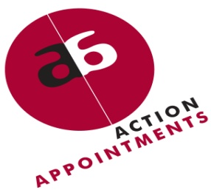
ACTION APPOINTMENTS BIO-SUMMARY
PO Box 18081, Wynberg, 7824
Tel: (021) 761 4916
Fax: (021) 761 5999
Email: data@actionappointments.co.za
PERSONAL DETAILS
Surname and Title
First names
Nationality (If other, state type
of permit and validity period)
ID Number
Employment Equity (EE) Status
(SA citizens only)
Languages
Driver’s License and Own Vehicle (state code of license)
Contact details – contact numbers, email address and physical address
Current employment (State position and employer)
Current/last salary
(annual total cost to company)
Current geographical location
Preferred geographical location
Highest completed qualification
Notice Period
Have you ever been convicted of a criminal offence?
EDUCATION DETAILS
QUALIFICATION | INSTITUTION
EMPLOYMENT HISTORY (Last 3 jobs held only)
PERIOD EMPLOYED (dates from - to) | POSITION HELD | EMPLOYER
I hereby authorise Action Appointments to process any personal information provided by me in the course of my application for employment. I confirm that Action Appointments may retain my personal information for future matching on the understanding that my details may only be released to specific clients with my prior consent. I also confirm that:
- Action Appointments may retain my personal information in their database for future matching.
- Action Appointments may contact me when suitable opportunities arise.
- The information I have provided to Action Appointments is true, correct and up to date.

Name:
Date:

